
Costumes and storage concept



In terms of the customization of the character I was thinking you could add decals and change the visor around. For the decal location I was thinking to have one on the top of the head one on the stomach, back and either side. Below are some examples.




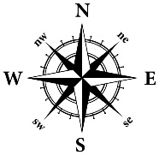

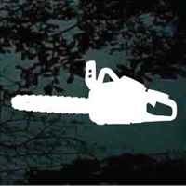


As for the inventory concepts I have had several ideas, either that they don’t get an inventory until they can unlock it, or they have a chest compartment and they need to unlock it relatively early on. Also, if the player hovers the inventory should be done on a mass system rather than an inventory slot system.

